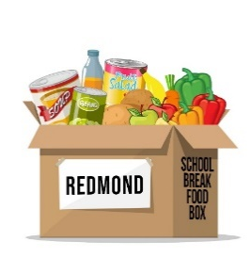
School Break Food Box Program
Volunteer Attestation

- I acknowledge that I am a volunteering for Redmond School Break Food Box Program, not as a requirement for any entity other than myself. As a driver, I will not hold Redmond Presbyterian Church, the School Break Food Box Program, or any team-member responsible for any injury or illness that may occur as a result of my participation in this activity.
- I attest that I am not exhibiting symptoms of the COVID-19 virus, nor have I been in close contact with someone who has.
I will:
- Practice social distancing, wear a mask, AND use precautions such as hand sanitizer or disposable gloves (gloves have been provided to me)
- Participate with the belief that I am in good health
- Stop any activity that seems too physically challenging
- Stop when I am tired
- Respect the confidentiality of the food box recipients
- Shred or return to the School Break Food Box Program team any hard copies of confidential information

````````````````````````````````````````````````````````````````````````````````````````````````````````````````````````````````````````````````````

By replying to this email with my e-signature, I acknowledge that I have read the information above and will adhere to its parameters.
(If you prefer, you may bring a signed hard copy of this document with you on Saturday.)

Signature: _______________________________________ Date: _________________

Thank you for your support!
We believe no person should ever go to bed, to school, or to work hungry; we know children learn better when they are fed, families function better when their needs are met, and engaged communities are powerful! Therefore, the Redmond School Break Food Box Program’s primary goals are to offer nutrition and hope to families experiencing food insecurity and to create a caring community where all people feel safe, valued, and important.

